Hi I have purchased eCommerce yesterday. And I unpacked ' hot_ecommerce_unzip_first' then unpacked 'hot_ecommerce_hotstart'.

1. Created a folder 'hot' (gave file permission 777) in 'public_html' which is root directory of my site.
2. Then uploaded unpacked 'hot_ecommerce_hotstart' to ../../hot.
3. Opened a browser and typed http://www.mysitename.co.in/hot/index.php
I got 404 error as below
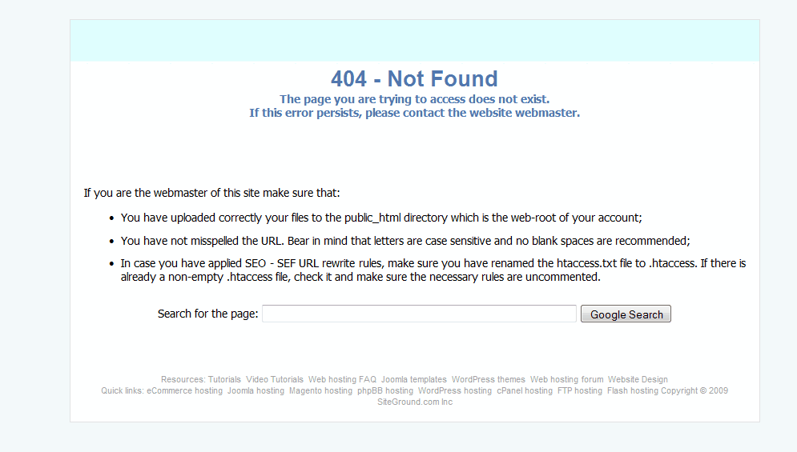
--> I checked whether I typed URL wrong (checked for 'spaces' / 'spelling mistakes'/'case'...etc)? No, it was correct.
--> Then I typed http://www.mysitename.co.in/public_html/hot/index.php
this time I included public_html
Still I got 404 error!
--> I found htaccess.txt in hot folder on my server, then I changed it to .htaccess as specified in the above error. And I tried loading the page by commenting 'one / two' lines in .htaccess after reading .htaccess carefully.
This time I got 500 error! (see screenshot below)
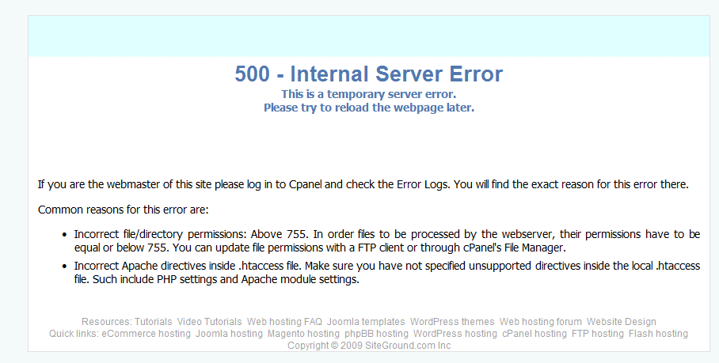
Can you tell me what is the issue?

