Changing pictures should not be cut short, should stay full size as on the “home” site.
Should not be like this:
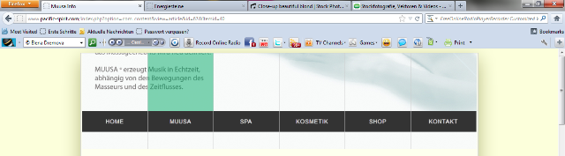

Should be like this and the text should be there as well. Just the same as on “Home”.


